Indie Band ‘So Long Storyland’ on NOLA music, style & Katrina
larkycanuck | October 30, 2014 | 0 Comments
You got to love social media for its adaptability in making instantaneous connections in foreign locations when traveling. It is especially valuable for travel bloggers like myself to identify unique trends, styles and culture to showcase to readers.
Thus I am excited to share with you an emerging talent out of New Orleans, that I discovered through a quick twitter search while walking along Canal Street of NOLA (that is short for New Orleans).
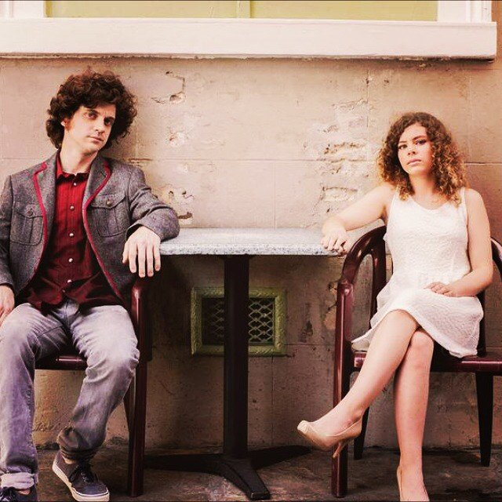
Courtesy of So Long Storyland
New Orleans is a global beacon of musical innovation rooted in various music genres that developed in the deep south, so when a group from NOLA speaks – well you listen!
So Long Storyland (formally known as Little White Lies) is one such indie band that represents the cornucopia of southeast Louisiana’s musical traditions by blending folk, bluegrass, pop, rick, electronic and orchestral music to tell a story. The band comprises locals singer Sophia Preston and songwriter Andrew deBuys. While in NOLA, I did not get a chance to meet this lovely duo (timing conflicts) but I did get to interview Andrew for an exclusive piece for my blog.
I will admit, I am not a music critic or knowledgeable enough to write on music talents. What I am good at is recognizing emerging talent (thanks to time spent at Genart in its early days) and writing about culture, travel, and style.
So for this interview piece, instead of focusing on the music and the band itself, I had Andrew share insights on NOLA culture and fashion, food, trends and how Hurricane Katrina impacted the local music scene.
A little briefer on your band. What influenced the band mates to collaborate?
I used to teach music at an all girls private school and one of my students was a girl named Sophia. One day she came to me with a song she wrote and I helped her with it. Then I started playing her songs I had written too. Next thing I know we’re in a studio recording them
Style of your music, how would one define it?
Orchestral pop folk vision music
What aspect of New Orleans influences the sound? Describe it through culture, sounds, food, or whatever.
I’d say it’s the landscape. The cracked streets, shotgun houses, the river, the people. It’s all there. New Orleans is a dirty city but we like it that way.
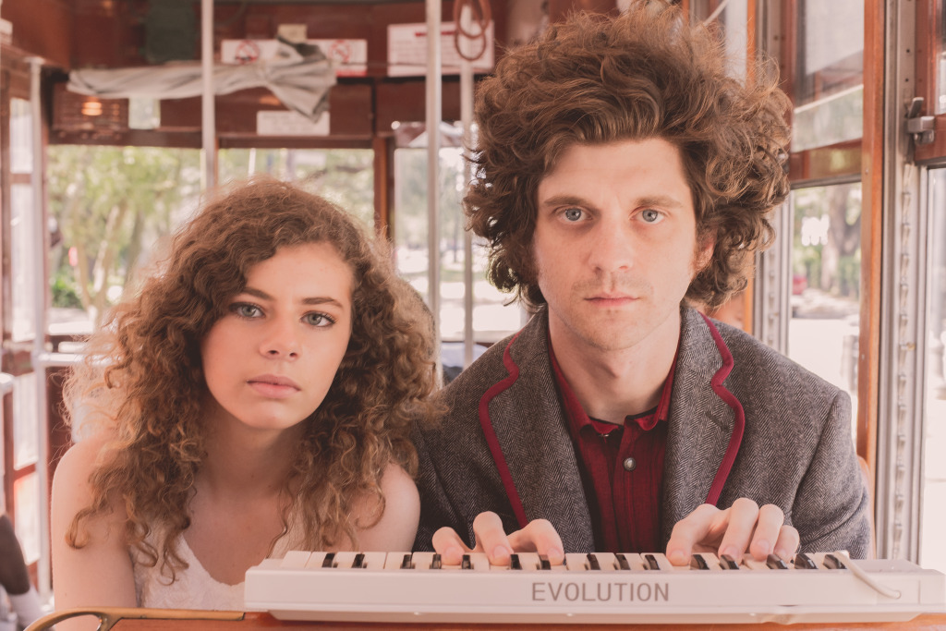
Courtesy of So Long Storyland
How has the music scene, traditionally Blues and Jazz, evolved in the past couple of years, especially since Hurricane Katrina?
It’s probably gotten stronger. NOLA is in many ways better than it ever was before Katrina. There’s a lot of people blowing in from other places and they come to pick up the traditions here. Blues, jazz, funk, bluegrass, folk can be heard all throughout the city and in the streets. Music is everywhere.
How did Katrina affect you guys (as individuals and as a band if either applies)?
I was away at college when Katrina hit so I didn’t experience it firsthand. My father lost his home. He lived on the very street where the canal broke in lakeview. He and my stepmother stayed on that property in a trailer for a few years until they were able to rebuild. They still live there today.
[Hurricane] Katrina had a huge impact on the local tourism industry. How did that affect the local musicians and native industry in this aspect?
Katrina peaks a lot of curiosity. People come to see the tragedy. There are Katrina tours now and museum exhibits. We’ve got the red double decker buses too like they do in London. I never saw that before but it’s here now. The show “Treme” did a lot to raise interest in our music scene. And Treme wouldn’t have happened if it weren’t for Katrina. Everyone seems to know about Frenchmen now and everything going on down here. Katrina helped the tourism industry a lot.
If you were to describe New Orleans as a fruit what would it be and why?
Mangoes but I don’t know why.
[Blogger's Note: Louisiana weather is not conducive for growth of mangoes. But leave it to the internetarrazzi to figure out a way here]
What places would you recommend for checking out the latest evolution of NOLA sounds (music scene)?
Freret’s cool. I really like Gasa Gasa. There’s usually something different happening there. So much of New Orleans is about blues and funk, I appreciate the other scenes. I like One Eyed Jacks in the quarter. They book great bands and I love the vibe of that place. 3 Muses and DBA on Frenchman are good too.
[Blogger's Note: This blog will cover a story on Freret Street. Stay tuned]
Whats one local designer (clothing or accessories) shop you would recommend for newbies in town to check out?
Muse on St Peter in Jackson square. They’ve got some great clothing, real loud but tasteful. If your looking for local shirts, try Branch Out or Funky Monkey on Magazine St.
Courtesy of So Long Storyland
The band’s website is www.solongstoryland.com
Acknowledgement: This interview would not be possible without the help of Band Manager, Lisa Musso. Thank you Lisa.
Blogging is a labor of love. If you enjoyed reading this, please share.
(Visited 542 time, 1 visit today)

Share this:
- Email
- Print
- Facebook41
- LinkedIn1
- Reddit
- StumbleUpon
- Twitter5
- Google
- Tumblr
- Pocket
- Pinterest

Tags: Andrew deBuys, Branch out clothing, Funky Monkey Clothing, Indie Bands, Little White Lies (former name), Muse Fashion, Music, New Orleans Travel, NOLA, So Long Storyland, Sophia Preston
Category: Budget Adventure Travel, New Orleans, USA Jaunts

About the Author (Author Profile)
Larkycanuck is the pseudonym for the spirited, spontaneous and zestful Canadian. The Blog is focused on showcasing budget adventure travels for working families. Larkycanuck has traveled to over 15 countries, 38 cities in 10 years. He has never quit a job to do this. He travels with his wife and on some trips with the house rabbit (Pepper).

